Submit your time, and share your experience!

Vacation & Time-Off Tracker

Vacation & Time-Off Tracker

Programmer: Jason Devereaux

**Project Overview**

The application I am proposing is a Vacation & Time-Off Tracker that will allow students to submit their time-off requests for their in-school absences and then share their vacation experiences with their classmates. Through the use of preferences established by each student, this web application can then make positive vacation trip recommendations to other students who share similar interests.

While students technically do not receive “free” vacation, sick, and personal days while enrolled in college courses, this web application does serve as a communication vehicle between student and professor to when prolonged vacation or travel is required by the student that jeopardizes the ability to complete assignments on-time. Examples include family travel, weddings/honeymoons, death of loved ones, sicknesses, etc.

**Application Goals**

The purpose of my application is three-fold. First, it provides a mechanism for students to submit time-off requests and inform professors when prolonged absences are needed. Proper expectations can be established for assignments that will/may be delayed by the absences, and the professor can respond with their agreement or disagreement to allow for assignment extensions. Business logic will govern when the professor needs to approve the time-off request e.g. when the student exceeds their time-off balance allotment. Second, it enables the student to track their time-off balances and use balances before they expire. In a real-world professional career, employees earn time-off based upon their tenure with a company, and vacation, sick leave, and personal days are allotted accordingly. My application will determine these allotments based upon the date on which the student began their Master’s Degree journey, which is equivalent to their tenure. Business logic will determine these ranges and how to apply these allotments. Third, it provides a platform for students to share their vacation destination experiences with other classmates so that the application can provide recommendations to other students who share similar interests, determined by preferences set by each student. Other students with available or upcoming vacation days can preview these trips, blog on them, and connect with the student who took the trip.

Minimum Viable Product (MVP)

The following requirements must be met in order to deploy the Vacation & Time-Off Tracker web application for student and professor use.

**Personas**

**No changes. There are two main personas that this application will benefit - the student, the primary user, who needs to request time-off and desires to share their vacations with others and the professor who needs to know [and potentially approve] when students will be absent or unable to complete their time-bound assignments on-time.

**Web Application Wireframes**

The Vacation & Time-Off Tracker application will be accessible via URL and will launch the following: **New footer menu links were added.



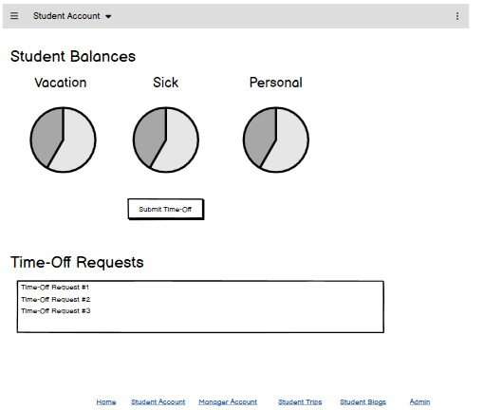



**In addition to new footer menu picks, an ALERT box was added to inform when a student’s timeoff request exceeds their available balance:



**New Manager Account pages were added for professors to maintain their profile information as well as review student timeoff requests in need of approval:



(continued on next page)

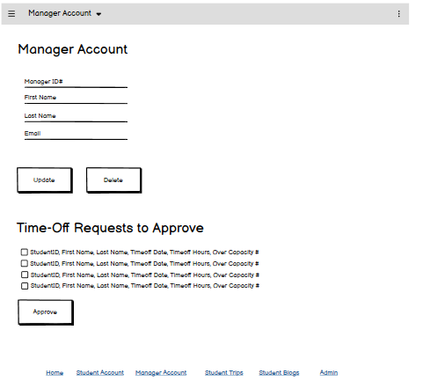



**Student Vacations was renamed to Student Trips:



**Student Vacations should’ve been Student **Blogs** on the original design.



**New Admin pages were added so that PostgreSQL INSERT statements aren’t required:



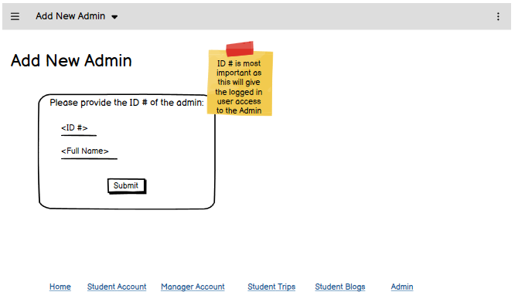



**Storyboards**

**New pages were added for Manager Account, Admin, and Manage Preferences:



Navigation bar (student) Home Student Account Student Trips Student Blogs



Navigation bar (manager) Home Student Account Manager Account Student Trips Student Blogs

Navigation bar (admin) Home Student Account Manager Account Student Trips Student Blogs Admin



**Style Guide**\*\*No changes

(continued on next page)

Primary font: Bernard MT Condensed

Secondary font: Amasis MT Pro Black

Paragraph font: Aptos